Epicurean Club of Boston 1st Annual Dyno-Glo Grill Raffle
Enter to Win this beautiful Dyno-Glo 5 Burner Grill to be Raffled off on March 31st,2021.
All Proceeds go to the Epicurean Club of Boston Culinary Scholarship Fund. You can purchase your tickets online or your can request a book of ten from any of the Board of Directors.
Or call John DiSessa CEC,AAC or Tim Foley at the numbers below to get tickets
Tickets are 10.00 each. Spring Grilling will be here soon so do not be left out.
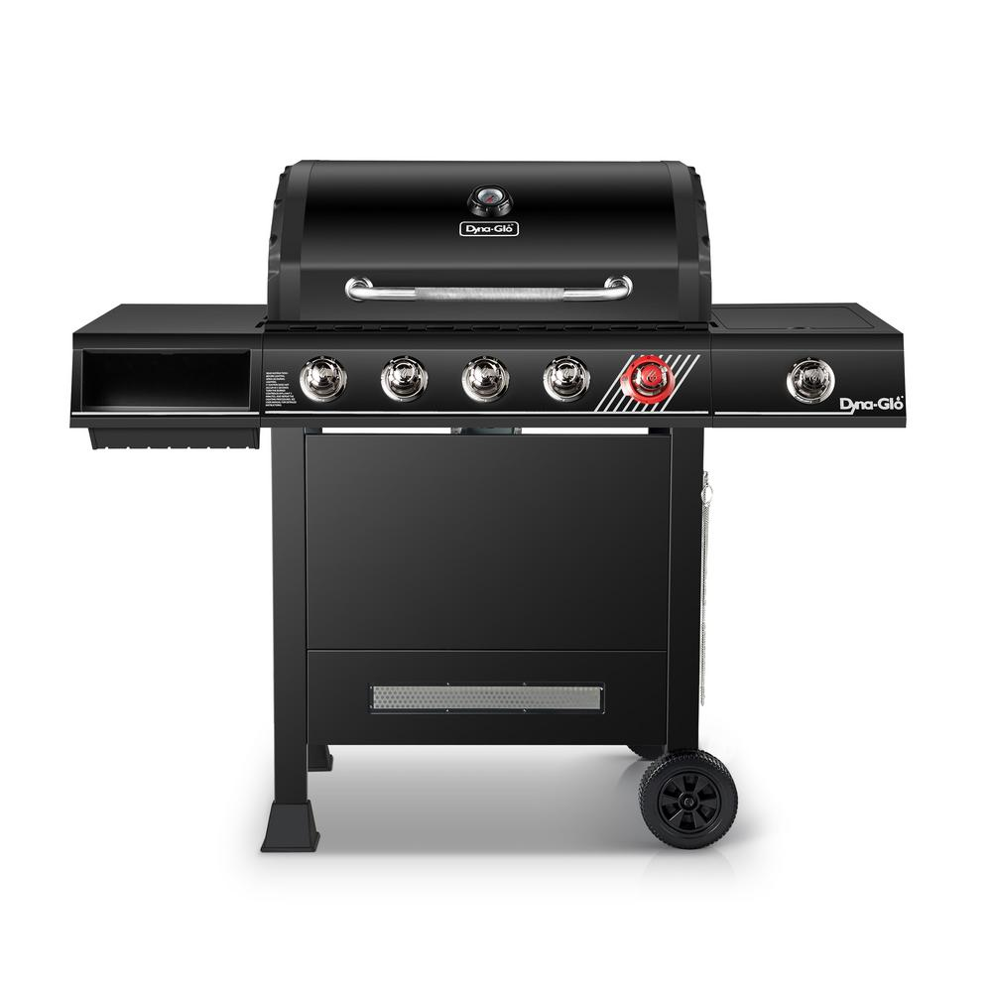John DiSessa – Cell # 978-990-3361
Tim Foley -Cell number 774-270-4828

